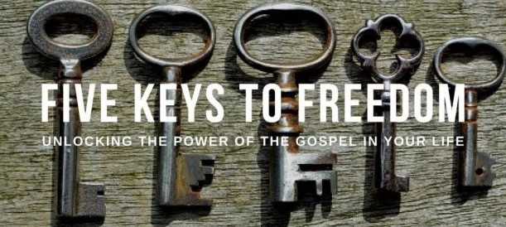
BEGINNING Monday evening, January 14th:
UNBOUND: Freedom in Christ – an eight week series of workshops which present a sound and practical way to experience greater freedom from the influence of evil in one’s life and enjoy a greater fullness of life, won for us by Christ’s resurrection and death. These workshops help participants respond to the good news of the Gospel and apply truth to their lives.
The goal of the workshops and associated prayer ministry is for attendees to learn to use the model, understood as the “Five Keys to Freedom” found in the Gospel, for themselves as a regular part of their prayer life. It is simple, undramatic, and yet very powerful.
The workshops are: Deliverance is a Good Word, Repentance & Faith, Freedom in Christ, Renunciation & Authority, The Power of Forgiveness, Partnering with the Holy Spirit, The Battle for Our Minds, and The Father’s Blessing.
Through the Five Keys participants will learn how to win their ongoing spiritual battles, and experience the freedom to be who God meant them to be and to live the life the abundant life Jesus meant them to live.
Here’s a link to the explanation of why UNBOUND’s Five Keys are so important in the Christian life: https://www.youtube.com/watch?v=NId-dGQbVSw
You can view a testimony of a person who received inner healing and was set free from anxiety at https://www.youtube.com/watch?v=DXkgIroXS5w&t=129s
Another testimony of a person healed of an inner wound and scar from her childhood can be found at https://www.youtube.com/watch?v=xCTnjyZSncA
Sessions will be held at St. Mary’s, Galesville, beginning Monday, January 14th at 6:30 PM. Please register by Monday January 7th. Email kent73j@msn.com or leave a message at 608-582-4138.

